Computer Science 2212b
Team Assignment 4
Team 10

Due: March 26th, 2014 at 11:59 PM

Team Members:
Henrique Brighenti
Will Callaghan
Alex MacLean
Stephen Solis
Marcus Tonogai

SECTION 1: REVISED USER STORIES

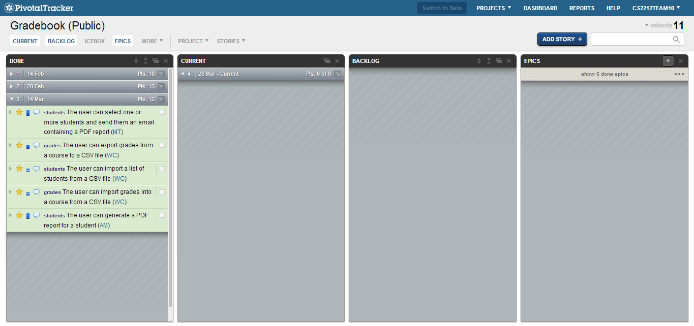

https://www.pivotaltracker.com/s/projects/1003292

Completed User Stories:
- User can email one or more students a .pdf report of their grades
  - Click the email button near the top
  - Then select the students you wish the send reports to
  - Hit “Email”
- User can export grades from a course to a .csv file
  - Click the File file menu and go to Export -> Export grades to CSV file
  - Then choose a destination to save the .csv file to
  - Click “Save”
- User can import a list of students from a .csv file
  - Go to File file menu -> Import -> Import student from CSV file
  - Choose .csv file
  - Click “Open”
- User can generate a .pdf report for each student
  - Click the “Generate Reports” button near the top
  - Select the students you wish to generate reports for
  - Choose a destination to save them to
  - Click “Generate”

SECTION 2: PROJECT VIDEO

Video link

SECTION 3: PROJECT PLAN

SECTION 4: UNIT TESTS

Non-GUI Classes:
- Course
- DataProvider
- Deliverable
- DuplicateStudentException
- Gradebook
- JavaBean
- Student

GUI Classes:
- AppLauncher
- CustomFileChooser
- DoubleCellEditor
- MainWindow
- TableModel
- UserEntryPrompter

